Name:Pranav Sarda
Gr No: 21810773
Roll No: 321047
Div: A-2
CODE :-
3A :-
%{
/*
*To implement a lexical analyzer for parts of speech without Symbol Table
*/
%}
VERB is|am|are|brought|disappeared|likes|exhausted|touch|trade|goes|down
ADVERB very|I|quickly|tentatively|down
PREPOSITION to|from|behind|below|between|at|of|in
CONJUCTION if|then|and|but|or|until
ADJECTIVE his|young|long|two
NOUN boy|girl|John|letter|teacher|house|street|end|center|ring|boxers|gloves|punches|champ
PRONOUN me|she|who|his
DETERMINER a|the
INTERJECTION Oh!|Wow!|Oops!

%%

[ \n\t]+ ;
{VERB} { printf("%s\t==> VERB\n",yytext); }
{ADVERB} { printf("%s\t==> ADVERB\n",yytext); }
{PREPOSITION} { printf("%s\t==> PREPOSITION\n",yytext); }
{CONJUCTION} { printf("%s\t==> CONJUCTION\n",yytext); }
{ADJECTIVE} { printf("%s\t==> ADJECTIVE\n",yytext); }
{NOUN} { printf("%s\t==> NOUN\n",yytext); }
{PRONOUN} { printf("%s\t==> PRONOUN\n",yytext); }
{DETERMINER} { printf("%s\t==> DETERMINER\n",yytext); }
{INTERJECTION} { printf("%s\t==> INTERJECTION\n",yytext); }
. ;

%%

int yywrap(void){ }
int main()
{
yylex();
return 0;
}

OUTPUT :-
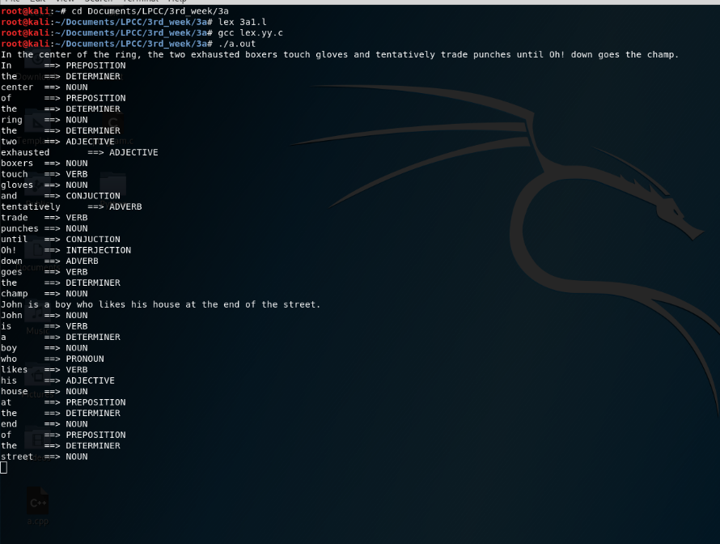

3C:-
%{
%}
DIGIT [0-9]
NUMBER [-+]?[0-9]*|[-+]?[0-9]*[.][0-9]+
TEXT [A-Za-z]
PREPROCESSOR #include|#define|#undef
HEADERFILE [a-z]+\.h
KEYWORDS auto|break|case|const|continue|default|enum|extern|goto|register|return|signedsizeof|static|struct|switch|typedef|union|unsigned|volatile
INBUILT printf|scanf|clrscr\(\)|getch\(\)|main\(\)
DATATYPE boolean|protected|double|byte|int|short|void|char|long|float
CONDITIONAL if|switch|else|case
ITERATIVE while|for|do
STRINGLITERAL \"[^\n]*\"
IDENTIFIER [A-Za-z$_]({DIGIT}|{TEXT}|_|$)*
ARITH_OP "+"|"-"|"/"|"%"|"*"
LOGICAL_OP "&&"|"||"|"!"|"!="
REL_OP "<"|">"|"<="|">="|"=="
UNARY "++"|"--"
SC "."|"{"|"}"|","|":"|"'"|";"|"("|")"
FORMATSPECIFIER %d|%c|%s|%f
%%
[ \n\t]+ ;
{NUMBER} { printf("%s\t==> NUMBER\n",yytext); }
{PREPROCESSOR} { printf("%s\t==> PREPROCESSOR\n",yytext); }
{HEADERFILE} { printf("%s\t==> HEADERFILE\n",yytext); }
{KEYWORDS} { printf("%s\t==> KEYWORDS\n",yytext); }
{INBUILT} { printf("%s\t==> INBUILTFUNC\n",yytext); }
{DATATYPE} { printf("%s\t==> DATATYPE\n",yytext); }
{CONDITIONAL} { printf("%s\t==> CONDITIONAL\n",yytext); }
{ITERATIVE} { printf("%s\t==> ITERATIVE\n",yytext); }
{IDENTIFIER} { printf("%s\t==> IDENTIFIER\n",yytext); }
{ARITH_OP} { printf("%s\t==> ARITHMETIC OPERATOR\n",yytext); }
{LOGICAL_OP} { printf("%s\t==> LOGICAL OPERATOR\n",yytext); }
{REL_OP} { printf("%s\t==> RELATIONAL OPERATOR\n",yytext); }
{UNARY} { printf("%s\t==> UNARY OPERATOR \n",yytext); }
{SC} { printf("%s\t==> PUNCTUATION\n",yytext); }
{FORMATSPECIFIER} { printf("%s\t==> FORMAT SPECIFIER\n",yytext); }
{STRINGLITERAL} { printf("%s\t==> STRINGLITERAL\n",yytext); }
"=" { printf("%s\t==> ASSIGNMENT OP\n",yytext); }
. ;
%%
int yywrap(void){ }
int main()
{
yylex();
return 0;
}
OUTPUT:-
